MOTION, RHYTHM, SHIFTS
New England Renaissance Conference 2019
Saturday 5 October
RISD Museum, Metcalf Auditorium, 9-6pm

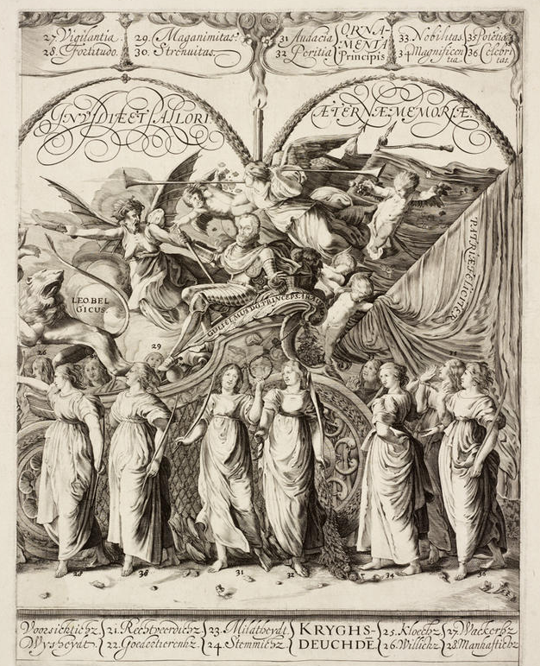

Presentations Moriscos and Muslims in Christian Festivities in Early Modern Iberia , Borja Franco Llopis, UNED Madrid / Mediterranean Crossings: The King of Tunis at Habsburg Courts, Cristelle Baskins, Tufts/ Imaginary Passings: Shifting Genres and Syncopated Time in the Entry of the Queen Gijllette, Daniel Ruppel, Brown U. & Roger Williams U. / On the Use of Roman and Arabic Numerals in Earliest Printed Books, William S. Monroe, Hay library / Arhythmic Reading and Alchemical Practice, Tara Nummedal, Brown University / “The highways are stopp’d with them”: Circulation through the City in The Roaring Girl (1611), Chris Yates, Brown University / Counterpoint, Improvisation, and Bodies in Motion, Todd Borgerding, Rhode Island College

Prints & Drawings Exhibition (Jamie Gabbarelli) / Tempera painting demo (Rich Gann) / Engraving workshop (Andrew Raftery)/ Museum tours (Maureen O' Brien, Suzanne Scanlan, Susan Ward, Pascale Rihouet)

CONCERT by the Hope Collective for Early Music AND RECEPTION (Fleet library)

Free Registration but mandatory: https://www.new-england-renaissance-conference.org

